PANCAR WAHYU

H1D024018

SHIFT D

1. Table customers

MariaDB [orderentry]> select * from customers;

Empty set (0.006 sec)

MariaDB [orderentry]> insert into customers values('10002','Mouse House','333 Fromage Lane','Columbus','OH','4333','USA','Jerry Mouse','NULL');

Query OK, 1 row affected (0.014 sec)

MariaDB [orderentry]> insert into customers values('10003','Wascals','1 Sunny Place','Muncie','IN','42222','USA','Jim Jones','rabbit@wascally.com');

Query OK, 1 row affected (0.014 sec)

MariaDB [orderentry]> insert into customers values('10004','Yosemite Place','829 Riverside Drive','Phoenix','AZ','88888','USA','Y Sam','sam@yosemite.com');

Query OK, 1 row affected (0.007 sec)

MariaDB [orderentry]> insert into customers values('10005','E Fudd','4545 53rd Street','Chicago','IL','54545','USA','E Fudd','NULL');

Query OK, 1 row affected (0.014 sec)

MariaDB [orderentry]> select * from customers;

+---------+----------------+---------------------+-----------+------------+----------+--------------+---------------+---------------------+

| cust_id | cust_name | cust_address | cust_city | cust_state | cust_zip | cust_country | cust_contract | cust_email |

+---------+----------------+---------------------+-----------+------------+----------+--------------+---------------+---------------------+

| 10002 | Mouse House | 333 Fromage Lane | Columbus | OH | 4333 | USA | Jerry Mouse | NULL

|

| 10003 | Wascals | 1 Sunny Place | Muncie | IN | 42222 | USA | Jim Jones | rabbit@wascally.com |

| 10004 | Yosemite Place | 829 Riverside Drive | Phoenix | AZ | 88888 | USA | Y Sam | sam@yosemite.com |

| 10005 | E Fudd | 4545 53rd Street | Chicago | IL | 54545 | USA | E Fudd | NULL

|

+---------+----------------+---------------------+-----------+------------+----------+--------------+---------------+---------------------+

4 rows in set (0.000 sec)



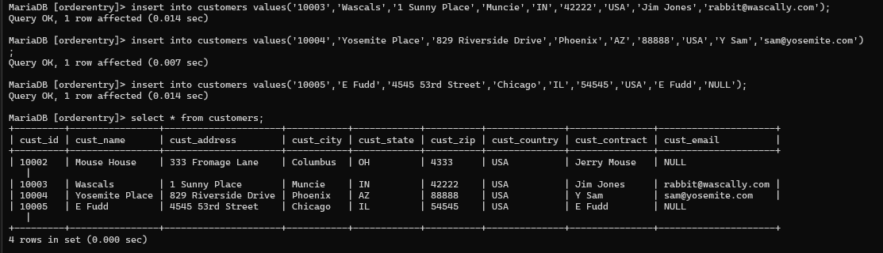

1. Table vendors

MariaDB [orderentry]> select*from vendors;

Empty set (0.005 sec)



MariaDB [orderentry]> insert into vendors values('1001','Anvils R Us','123 Main Street','Southfield','MI','48075','USA');

Query OK, 1 row affected (0.006 sec)

MariaDB [orderentry]> insert into vendors values('1002','LT Supplies','500 Park Street','Anytown','OH','44333','USA');

Query OK, 1 row affected (0.005 sec)

MariaDB [orderentry]> insert into vendors values('1003','ACME','555 High Street','Los Angeles','CA','90046','USA');

Query OK, 1 row affected (0.001 sec)

MariaDB [orderentry]> insert into vendors values('1004','Furball Inc.','1000 5th Avenue','New York','NY','11111','USA');

Query OK, 1 row affected (0.011 sec)

MariaDB [orderentry]> insert into vendors values('1005','Jet Set','42 Galaxy Road','London','NULL','N16 6PS','England');

Query OK, 1 row affected (0.006 sec)

MariaDB [orderentry]> insert into vendors values('1006','Jouets Et Ours','1 Rue Amusement','Paris','NULL','45678','France');

Query OK, 1 row affected (0.007 sec)

MariaDB [orderentry]> select * from vendors;

+---------+----------------+-----------------+-------------+------------+----------+--------------+

| vend_id | vend_name | vend_address | vend_city | vend_state | vend_zip | vend_country |

+---------+----------------+-----------------+-------------+------------+----------+--------------+

| 1001 | Anvils R Us | 123 Main Street | Southfield | MI | 48075 | USA |

| 1002 | LT Supplies | 500 Park Street | Anytown | OH | 44333 | USA |

| 1003 | ACME | 555 High Street | Los Angeles | CA | 90046 | USA |

| 1004 | Furball Inc. | 1000 5th Avenue | New York | NY | 11111 | USA |

| 1005 | Jet Set | 42 Galaxy Road | London | NULL | N16 6PS | England |

| 1006 | Jouets Et Ours | 1 Rue Amusement | Paris | NULL | 45678 | France |

+---------+----------------+-----------------+-------------+------------+----------+--------------+

6 rows in set (0.000 sec)

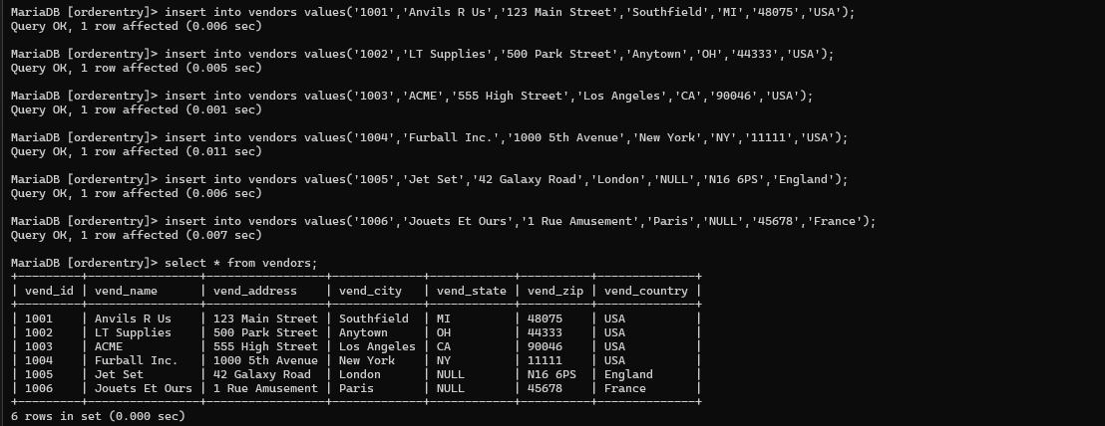

1. Table products

MariaDB [orderentry]> select *from products;

Empty set (0.005 sec)



MariaDB [orderentry]> insert into products values('ANV01','1001','5 ton anvil','6','5 ton anvil, black, complete with handy hook');

Query OK, 1 row affected (0.006 sec)

MariaDB [orderentry]> insert into products values('ANV02','1001','1 ton anvil','10','1 ton anvil, black, complete with handy hook and carrying case');

Query OK, 1 row affected (0.009 sec)

MariaDB [orderentry]> insert into products values('ANV03','1001','2 ton anvil','15','2 ton anvil, black, complete with handy book and carrying case');

Query OK, 1 row affected (0.002 sec)

MariaDB [orderentry]> insert into products values('DTNTR','1003','Detonator','13','Detonator (plunger powered), puses not included');

Query OK, 1 row affected (0.014 sec)

MariaDB [orderentry]> insert into products values('FB','1003','Bird Seed','10','Large bag (suitable for road runners)');

Query OK, 1 row affected (0.007 sec)

MariaDB [orderentry]> insert into products values('FC','1003','Carrots','3','Carrots (rabbit hunting season only)');

Query OK, 1 row affected (0.006 sec)

MariaDB [orderentry]> insert into products values('FU1','1002','Fuses','3','1 dozen, extra long');

Query OK, 1 row affected (0.008 sec)

MariaDB [orderentry]> insert into products values('JP1000','1005','JetPack 1000','35','JetPack 1000,intended for single use');

Query OK, 1 row affected (0.014 sec)

MariaDB [orderentry]> insert into products values('JP2000','1005','JetPack 2000','55','JetPack 2000, multi use');

Query OK, 1 row affected (0.007 sec)

MariaDB [orderentry]> insert into products values('OL1','1002','oil can','9','oil can,red');

Query OK, 1 row affected (0.003 sec)

MariaDB [orderentry]> insert into products values('SAFE','1003','Safe','50','Safe with combination look');

Query OK, 1 row affected (0.009 sec)

MariaDB [orderentry]> insert into products values('Sling','1003','Sling','4','Sling, one size fits all');

Query OK, 1 row affected (0.013 sec)

MariaDB [orderentry]> insert into products values('TNT1','1003','INT (1 stick)','3','TNT, red, single stick');

Query OK, 1 row affected (0.002 sec)

MariaDB [orderentry]> insert into products values('TNT2','1003','TNT (5 stick)','10','TNT, red, pack of 10 stick');

Query OK, 1 row affected (0.007 sec)

MariaDB [orderentry]> select * from products;

+---------+---------+---------------+------------+----------------------------------------------------------------+

| prod_id | vend_id | prod_name | prod_price | desc_prod |

+---------+---------+---------------+------------+----------------------------------------------------------------+

| ANV01 | 1001 | 5 ton anvil | 6 | 5 ton anvil, black, complete with handy hook |

| ANV02 | 1001 | 1 ton anvil | 10 | 1 ton anvil, black, complete with handy hook and carrying case |

| ANV03 | 1001 | 2 ton anvil | 15 | 2 ton anvil, black, complete with handy book and carrying case |

| DTNTR | 1003 | Detonator | 13 | Detonator (plunger powered), puses not included |

| FB | 1003 | Bird Seed | 10 | Large bag (suitable for road runners) |

| FC | 1003 | Carrots | 3 | Carrots (rabbit hunting season only) |

| FU1 | 1002 | Fuses | 3 | 1 dozen, extra long |

| JP1000 | 1005 | JetPack 1000 | 35 | JetPack 1000,intended for single use |

| JP2000 | 1005 | JetPack 2000 | 55 | JetPack 2000, multi use |

| OL1 | 1002 | oil can | 9 | oil can,red |

| SAFE | 1003 | Safe | 50 | Safe with combination look |

| Sling | 1003 | Sling | 4 | Sling, one size fits all |

| TNT1 | 1003 | INT (1 stick) | 3 | TNT, red, single stick |

| TNT2 | 1003 | TNT (5 stick) | 10 | TNT, red, pack of 10 stick |

+---------+---------+---------------+------------+----------------------------------------------------------------+

14 rows in set (0.000 sec)

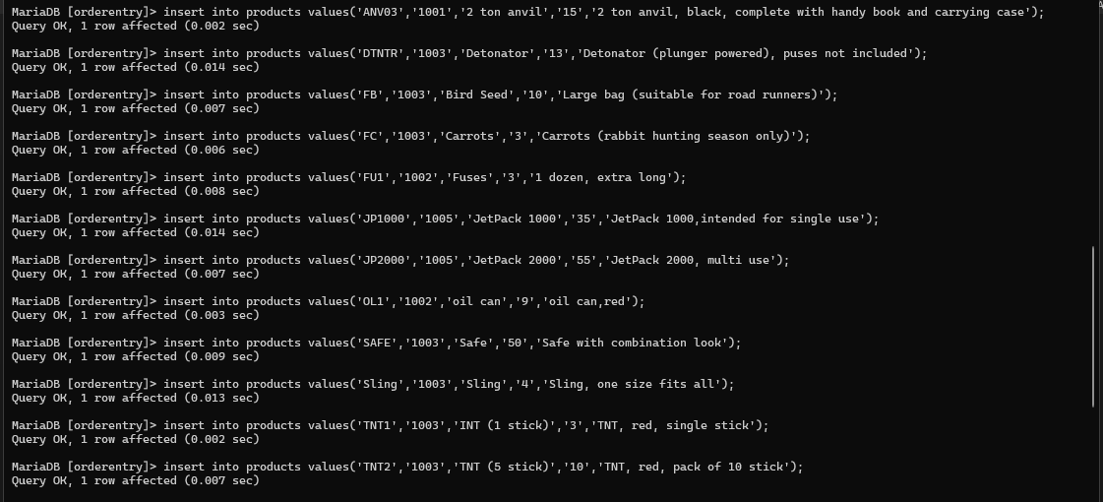

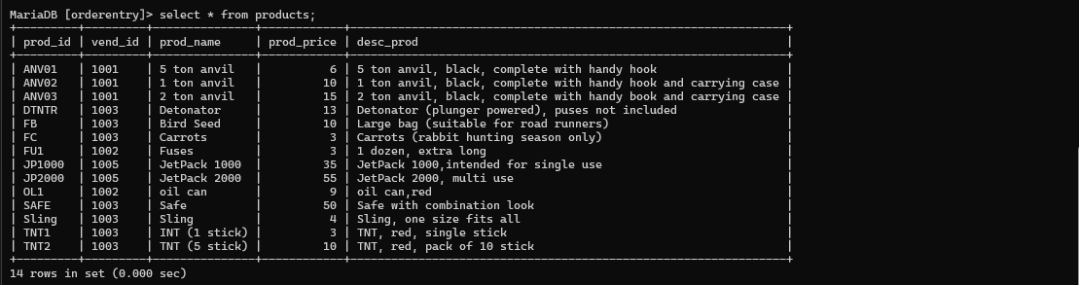

1. Table productnotes

MariaDB [orderentry]> select * from productnotes;

Empty set (0.011 sec)

MariaDB [orderentry]> insert into productnotes values('001','ANV01','2010-09-17','terbayar');

Query OK, 1 row affected (0.002 sec)

MariaDB [orderentry]> insert into productnotes values('002','FB','2017-11-19','terbayar');

Query OK, 1 row affected (0.008 sec)

MariaDB [orderentry]> insert into productnotes values('003','SAFE','2021-07-22','terbayar');

Query OK, 1 row affected (0.007 sec)

MariaDB [orderentry]> select * from productnotes;

+---------+---------+------------+-----------+

| note_id | prod_id | note_date | note_text |

+---------+---------+------------+-----------+

| 001 | ANV01 | 2010-09-17 | terbayar |

| 002 | FB | 2017-11-19 | terbayar |

| 003 | SAFE | 2021-07-22 | terbayar |

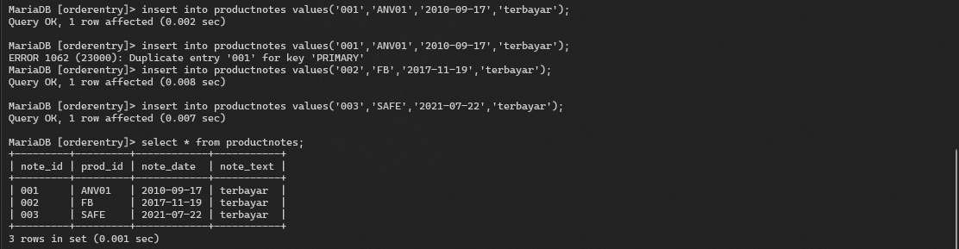+---------+---------+------------+-----------+

1. Table orders

MariaDB [orderentry]> select * from orders;

Empty set (0.009 sec)



MariaDB [orderentry]> insert into orders values('20005','2005-09-01','10002');

Query OK, 1 row affected (0.014 sec)

MariaDB [orderentry]> insert into orders values('20006','2005-09-28','10002');

Query OK, 1 row affected (0.014 sec)

MariaDB [orderentry]> insert into orders values('20007','2005-09-30','10004');

Query OK, 1 row affected (0.004 sec)

MariaDB [orderentry]> insert into orders values('20008','2005-09-03','10005');

Query OK, 1 row affected (0.004 sec)

MariaDB [orderentry]> insert into orders values('20009','2005-08-10','10003');

Query OK, 1 row affected (0.003 sec)

MariaDB [orderentry]> select * from orders;

+-----------+------------+---------+

| order_num | order_date | cust_id |

+-----------+------------+---------+

| 20005 | 2005-09-01 | 10002 |

| 20006 | 2005-09-28 | 10002 |

| 20007 | 2005-09-30 | 10004 |

| 20008 | 2005-09-03 | 10005 |

| 20009 | 2005-08-10 | 10003 |

+-----------+------------+---------+

5 rows in set (0.000 sec)

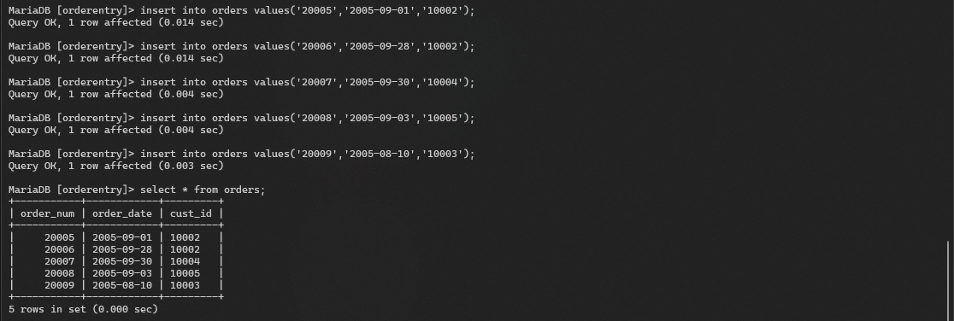

1. Table orderitems

MariaDB [orderentry]> select * from orderitems;

Empty set (0.003 sec)

MariaDB [orderentry]> insert into orderitems values('20005','1','ANV01','10');

Query OK, 1 row affected (0.003 sec)

MariaDB [orderentry]> insert into orderitems values('20005','2','ANV02','3');

Query OK, 1 row affected (0.015 sec)

MariaDB [orderentry]> insert into orderitems values('20005','3','TNT2','5');

Query OK, 1 row affected (0.005 sec)

MariaDB [orderentry]> insert into orderitems values('20005','4','FB','1');

Query OK, 1 row affected (0.014 sec)

MariaDB [orderentry]> insert into orderitems values('20006','1','JP2000','1');

Query OK, 1 row affected (0.008 sec)

MariaDB [orderentry]> insert into orderitems values('20007','1','TNT2','1');

Query OK, 1 row affected (0.015 sec)

MariaDB [orderentry]> insert into orderitems values('20008','1','FC','50');

Query OK, 1 row affected (0.008 sec)

MariaDB [orderentry]> insert into orderitems values('20009','1','FB','1');

Query OK, 1 row affected (0.007 sec)

MariaDB [orderentry]> insert into orderitems values('20009','2','OL1','1');

Query OK, 1 row affected (0.014 sec)

MariaDB [orderentry]> insert into orderitems values('20009','3','Sling','1');

Query OK, 1 row affected (0.002 sec)

MariaDB [orderentry]> insert into orderitems values('20009','4','ANV01','1');

Query OK, 1 row affected (0.003 sec)

MariaDB [orderentry]> select * from orderitems;

+-----------+------------+---------+----------+

| order_num | order_item | prod_id | quantity |

+-----------+------------+---------+----------+

| 20005 | 1 | ANV01 | 10 |

| 20006 | 1 | JP2000 | 1 |

| 20007 | 1 | TNT2 | 1 |

| 20008 | 1 | FC | 50 |

| 20009 | 1 | FB | 1 |

| 20005 | 2 | ANV02 | 3 |

| 20009 | 2 | OL1 | 1 |

| 20005 | 3 | TNT2 | 5 |

| 20009 | 3 | Sling | 1 |

| 20005 | 4 | FB | 1 |

| 20009 | 4 | ANV01 | 1 |

+-----------+------------+---------+----------+

11 rows in set (0.000 sec)

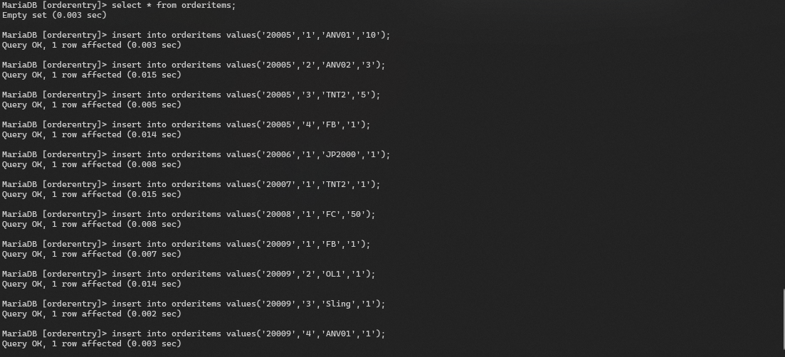

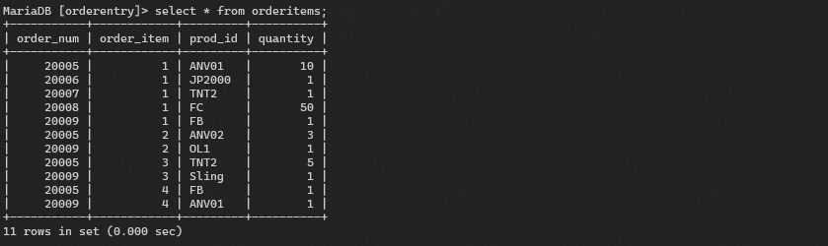

1. Setelah keempat table diisi query berikut

* Ubahlah data salah satu data customers dengan perintah update

Before

MariaDB [orderentry]> select * from customers;

+---------+----------------+---------------------+-----------+------------+----------+--------------+---------------+---------------------+

| cust_id | cust_name | cust_address | cust_city | cust_state | cust_zip | cust_country | cust_contract | cust_email |

+---------+----------------+---------------------+-----------+------------+----------+--------------+---------------+---------------------+

| 10002 | Mouse House | 333 Fromage Lane | Columbus | OH | 4333 | USA | Jerry Mouse | NULL |

| 10003 | Wascals | 1 Sunny Place | Muncie | IN | 42222 | USA | Jim Jones | rabbit@wascally.com |

| 10004 | Yosemite Place | 829 Riverside Drive | Phoenix | AZ | 88888 | USA | Y Sam | sam@yosemite.com |

| 10005 | E Fudd | 4545 53rd Street | Chicago | IL | 54545 | USA | E Fudd | NULL |

+---------+----------------+---------------------+-----------+------------+----------+--------------+---------------+---------------------+

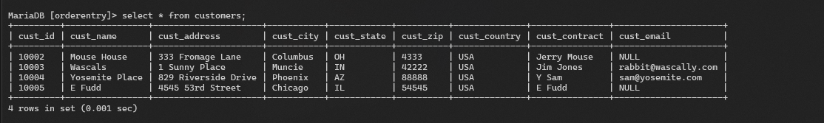4 rows in set (0.001 sec)

After

MariaDB [orderentry]> update customers set cust_name="Unsoed Place" where cust_id='10004';

Query OK, 1 row affected (0.008 sec)

Rows matched: 1 Changed: 1 Warnings: 0

MariaDB [orderentry]> select * from customers;

+---------+--------------+---------------------+-----------+------------+----------+--------------+---------------+---------------------+

| cust_id | cust_name | cust_address | cust_city | cust_state | cust_zip | cust_country | cust_contract | cust_email |

+---------+--------------+---------------------+-----------+------------+----------+--------------+---------------+---------------------+

| 10002 | Mouse House | 333 Fromage Lane | Columbus | OH | 4333 | USA | Jerry Mouse | NULL |

| 10003 | Wascals | 1 Sunny Place | Muncie | IN | 42222 | USA | Jim Jones | rabbit@wascally.com |

| 10004 | Unsoed Place | 829 Riverside Drive | Phoenix | AZ | 88888 | USA | Y Sam | sam@yosemite.com |

| 10005 | E Fudd | 4545 53rd Street | Chicago | IL | 54545 | USA | E Fudd | NULL |

+---------+--------------+---------------------+-----------+------------+----------+--------------+---------------+---------------------+

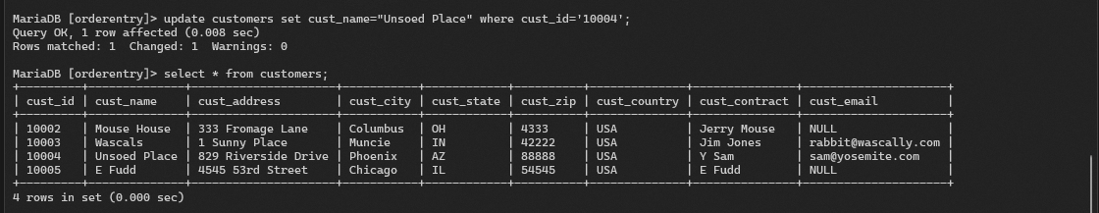4 rows in set (0.000 sec)

* Hapuslah salahsatu vendors atau product dengan perintah delete

Before

MariaDB [orderentry]> select * from vendors;

+---------+----------------+-----------------+-------------+------------+----------+--------------+

| vend_id | vend_name | vend_address | vend_city | vend_state | vend_zip | vend_country |

+---------+----------------+-----------------+-------------+------------+----------+--------------+

| 1001 | Anvils R Us | 123 Main Street | Southfield | MI | 48075 | USA |

| 1002 | LT Supplies | 500 Park Street | Anytown | OH | 44333 | USA |

| 1003 | ACME | 555 High Street | Los Angeles | CA | 90046 | USA |

| 1004 | Furball Inc. | 1000 5th Avenue | New York | NY | 11111 | USA |

| 1005 | Jet Set | 42 Galaxy Road | London | NULL | N16 6PS | England |

| 1006 | Jouets Et Ours | 1 Rue Amusement | Paris | NULL | 45678 | France |

+---------+----------------+-----------------+-------------+------------+----------+--------------+

6 rows in set (0.001 sec)

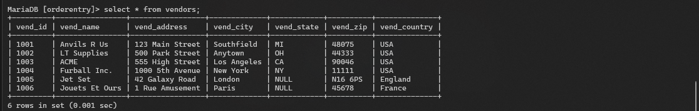

After

MariaDB [orderentry]> delete from vendors where vend_id='1006';

Query OK, 1 row affected (0.009 sec)

MariaDB [orderentry]> select * from vendors;

+---------+--------------+-----------------+-------------+------------+----------+--------------+

| vend_id | vend_name | vend_address | vend_city | vend_state | vend_zip | vend_country |

+---------+--------------+-----------------+-------------+------------+----------+--------------+

| 1001 | Anvils R Us | 123 Main Street | Southfield | MI | 48075 | USA |

| 1002 | LT Supplies | 500 Park Street | Anytown | OH | 44333 | USA |

| 1003 | ACME | 555 High Street | Los Angeles | CA | 90046 | USA |

| 1004 | Furball Inc. | 1000 5th Avenue | New York | NY | 11111 | USA |

| 1005 | Jet Set | 42 Galaxy Road | London | NULL | N16 6PS | England |

+---------+--------------+-----------------+-------------+------------+----------+--------------+

5 rows in set (0.001 sec)

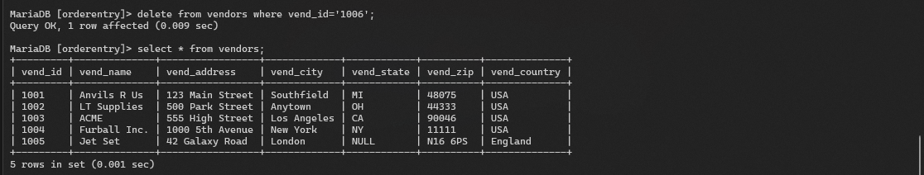

* Tampilkan nomor dan jumlahnya

MariaDB [orderentry]> select order_num, quantity from orderitems;

+-----------+----------+

| order_num | quantity |

+-----------+----------+

| 20005 | 10 |

| 20006 | 1 |

| 20007 | 1 |

| 20008 | 50 |

| 20009 | 1 |

| 20005 | 3 |

| 20009 | 1 |

| 20005 | 5 |

| 20009 | 1 |

| 20005 | 1 |

| 20009 | 1 |

+-----------+----------+

11 rows in set (0.001 sec)

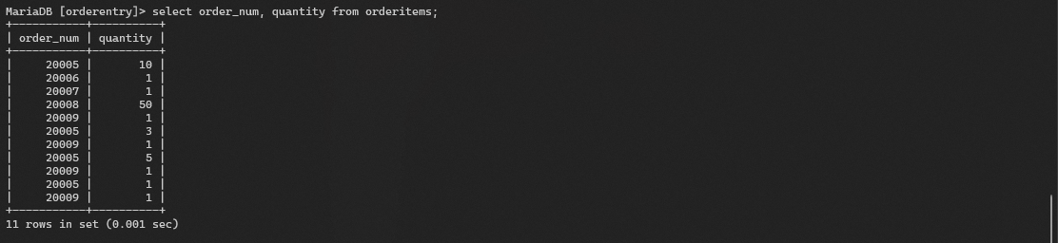

* Tampilkan data cutomers yang berasal dari ‘USA’

MariaDB [orderentry]> select cust_name, cust_country from customers where cust_country='USA';

+--------------+--------------+

| cust_name | cust_country |

+--------------+--------------+

| Mouse House | USA |

| Wascals | USA |

| Unsoed Place | USA |

| E Fudd | USA |

+--------------+--------------+

4 rows in set (0.003 sec)

